**B952** *Scheda creata il 6 dicembre 2023*

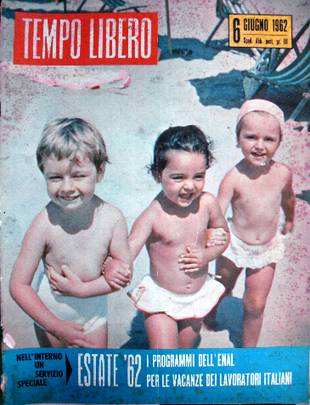 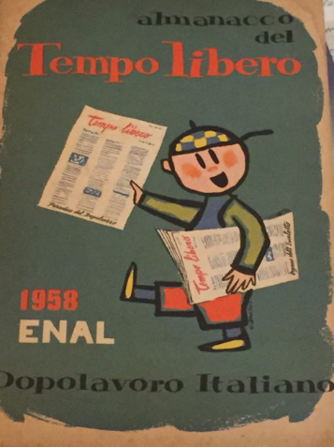

**Descrizione storico-bibliografica**

**\*Tempo libero** : rivista mensile dell'ENAL. - Anno 1, n. 1 (15 febbraio 1959)-anno 20, n. 11/12 (nov./dic. 1978). - Roma : [s. n.], 1959-1978 (Roma : ABETE). - 20 volumi : ill. ; 28 cm. ((Dal n. 5 (1961) il formato varia in: 34 cm. – BNI 59-815. - SBL0495957

Autore: Ente nazionale assistenza lavoratori <1945-1978>

\***Almanacco del tempo libero**. - 1958. - Roma : Edizioni Dopolavoro italiano, 1958. - 404 p. : ill. ; 20 cm. - IEI0126188 ; LO10554252

Soggetto: Almanacchi – 1958

Classe: D306.4812

Il \***nuovo tempo libero** : periodico mensile a carattere socio-culturale. - Anno 1, n. 1 (30 marzo 1980)-anno 20 (1999). - Roma : [s. n., 1980-1999]. – 20 volumi ; 30 cm. - CFI0327902

**\*Tempo libero** : periodico socio-culturale. – Anno 21 (settembre 2000)-n. 372/376 (ago.-dic. 2021). - Roma : FENALC, 2000-2021. – volumi : ill. ; 28 cm. ((Bimestrale irregolare. - CFI0517667

Autore: Federazione nazionale liberi circoli

Soggetto: Tempo libero - Aspetti socio-culturali – Periodici

Classe: D306.481205

**Volumi disponibili in rete**

[2006](https://www.google.com/url?sa=t&rct=j&q=&esrc=s&source=web&cd=&cad=rja&uact=8&ved=2ahUKEwiNjoOZhfuCAxXT7rsIHe_VBSI4HhAWegQIBxAB&url=http%3A%2F%2Fwww.fenalc.it%2Fimages%2FTEMPO_LIBERO_PDF%2F2006%2FTL-gen-nov-2006.pdf&usg=AOvVaw0xAYRbHBFs0slR_cWD0lMf&opi=89978449); [224(2007)](https://www.google.com/url?sa=t&rct=j&q=&esrc=s&source=web&cd=&cad=rja&uact=8&ved=2ahUKEwjPwqLCg_uCAxU6hf0HHW4yDnI4ChAWegQIAhAB&url=http%3A%2F%2Fwww.fenalc.it%2Fimages%2FTEMPO_LIBERO_PDF%2F2007%2FTL-nov-2007.pdf&usg=AOvVaw1cTCuUtBzq8gafcn8EvunX&opi=89978449); [255(2010)](https://www.yumpu.com/it/document/read/15381250/dodici-mesi-insieme-nel-mondo-del-sociale-fenalc); [gen. 2012](https://www.google.com/url?sa=t&rct=j&q=&esrc=s&source=web&cd=&ved=2ahUKEwjPwqLCg_uCAxU6hf0HHW4yDnI4ChAWegQIChAB&url=http%3A%2F%2Fwww.fenalc.it%2Fimages%2FTEMPO_LIBERO_PDF%2F2012%2FTL-gen-2012.pdf&usg=AOvVaw1tzT7mWSUo-qgphbo_UaEw&opi=89978449); ago.-set. [2013](https://www.google.com/url?sa=t&rct=j&q=&esrc=s&source=web&cd=&cad=rja&uact=8&ved=2ahUKEwi3pZqcgfuCAxUStKQKHRBDAYkQFnoECCIQAQ&url=http%3A%2F%2Fwww.fenalc.it%2Fimages%2FTEMPO_LIBERO_PDF%2F2013%2FTL-ago-2013.pdf&usg=AOvVaw1cX1KE2md3kjwJAhDtSW26&opi=89978449); [279(2013)](https://www.yumpu.com/it/document/view/16407026/lultimo-saluto-al-divo-giulio-federazione-nazionale-liberi-circoli); [gen.-feb. 2014](https://www.google.com/url?sa=t&rct=j&q=&esrc=s&source=web&cd=&ved=2ahUKEwi3pZqcgfuCAxUStKQKHRBDAYkQFnoECCQQAQ&url=https%3A%2F%2Fwww.fenalc.it%2Fimages%2FTEMPO_LIBERO_PDF%2F2014%2FTL-gen-feb-2014.pdf&usg=AOvVaw0yegVzIddHZ4-xo9EbRrLh&opi=89978449); [mag. 2014](https://www.google.com/url?sa=t&rct=j&q=&esrc=s&source=web&cd=&ved=2ahUKEwi3pZqcgfuCAxUStKQKHRBDAYkQFnoECB4QAQ&url=http%3A%2F%2Fwww.fenalc.it%2Fimages%2FTEMPO_LIBERO_PDF%2F2014%2FTL-mag-2014.pdf&usg=AOvVaw3BmejK6e1yCqG7CLC5CziM&opi=89978449); [mag. 2015](https://www.google.com/url?sa=t&rct=j&q=&esrc=s&source=web&cd=&cad=rja&uact=8&ved=2ahUKEwjMhKW_hfuCAxUlgf0HHeIkAO84KBAWegQICBAB&url=http%3A%2F%2Fwww.fenalc.it%2Fimages%2FTEMPO_LIBERO_PDF%2F2015%2FTL-mag-2015.pdf&usg=AOvVaw0AiL1Q5_isTIH5Zhf3L6IW&opi=89978449); [ago. 2015](https://www.google.com/url?sa=t&rct=j&q=&esrc=s&source=web&cd=&cad=rja&uact=8&ved=2ahUKEwj08IPqhPuCAxXNgP0HHVRUDfs4FBAWegQICxAB&url=http%3A%2F%2Fwww.fenalc.it%2Fimages%2FTEMPO_LIBERO_PDF%2F2015%2FTL-lug-ago-2015.pdf&usg=AOvVaw2Hvbz5i9b6jZmY9B_8rXZr&opi=89978449); [speciale 2015](https://www.google.com/url?sa=t&rct=j&q=&esrc=s&source=web&cd=&cad=rja&uact=8&ved=2ahUKEwiNjoOZhfuCAxXT7rsIHe_VBSI4HhAWegQIDRAB&url=http%3A%2F%2Fwww.fenalc.it%2Fimages%2FTEMPO_LIBERO_PDF%2F2015%2FTL-speciale-2015.pdf&usg=AOvVaw21qr0z57jfqfdlAzkxN4_w&opi=89978449); [ott.-dic. 2017](https://www.google.com/url?sa=t&rct=j&q=&esrc=s&source=web&cd=&ved=2ahUKEwjPwqLCg_uCAxU6hf0HHW4yDnI4ChAWegQIBBAB&url=http%3A%2F%2Fwww.fenalc.it%2Fimages%2FTEMPO_LIBERO_PDF%2F2017%2FTempoLibero-OTT-NOV-DIC-17.pdf&usg=AOvVaw2yVLFUEBr83GZKuxaL2zDB&opi=89978449); [giu. 2019](https://www.google.com/url?sa=t&rct=j&q=&esrc=s&source=web&cd=&ved=2ahUKEwj08IPqhPuCAxXNgP0HHVRUDfs4FBAWegQICRAB&url=http%3A%2F%2Fwww.fenalc.it%2Fimages%2FTEMPO_LIBERO_PDF%2F2019%2FTempoLibero-Giu-2019_w.pdf&usg=AOvVaw2Uc3bCx5XuqSc5v7bUwJXQ&opi=89978449); [2020-2021](http://www.fenalc.it/tempo-libero-2021)